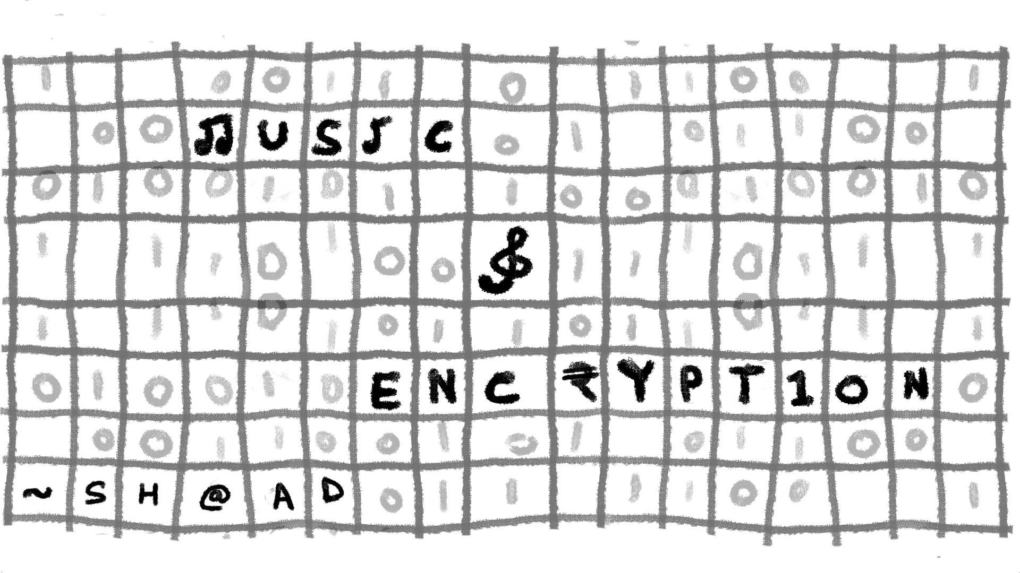

*My BLOG LINK :* [*https://shaadart.github.io/Tuned-Terminal-Blog/*](https://shaadart.github.io/Tuned-Terminal-Blog/)

***“I like beautiful melodies telling me terrible things.”***

***― Tom Waits***

Encryption doesn’t have to be boring code, it can be art. What if securing your data was as seamless as playing a song?

I am here talking about Music-Encryption, a revolutionary form of encryption that blends art and technology, offering new dimensions of privacy and security in our increasingly data-driven world.

Music encryption hides encrypted data within sound, using audio's frequencies and patterns to securely transmit information. It's a creative, stealthy alternative to traditional text-based encryption methods.

But Why Music?

## **Why Music?**

Traditional text-based encryption has long dominated the field of secure communication. Traditional encryption like RSA and AES[1] turns text into unreadable complex strings, protecting it from the intruding eyes. And, what if I told you that music—the universal language of emotion—could also serve as a robust medium for encrypting data?

### **Data Capacity** — Music offers multiple dimensions (e.g., rhythm, melody, harmony) to encode information, allowing more storage of large dataset in little space compared to linear, text-based encryption. Also, lossless formats like WAV or FLAC have immense storage potential[2].

### **Unique Attack Surface** — While text-based encryption can be vulnerable to brute force attacks, dictionary attacks, or pattern analysis, music introduces an entirely new attack surface. The vivid and versatile nature of sound makes it harder to analyze and attack the data, Sound is such a delicate thing that if it goes silent, finding it would be like searching for a needle in a haystack.

### **Disguised in Common Media** — Embedding encrypted data in music allows the message to blend into entertainment media, making it less noticeable to unintended listeners, unlike text files, which are more scrutinized.

### **Enormous Possibilities** — Music is a great medium for encryption because of its complex features like pitch, volume, timbre, duration, tempo, and spatiality. These elements create intricate patterns that can securely hide information. With billions of unique songs on Earth, music offers a fantastic way to store data secretly.

### By embedding information into music, we can develop unique and discreet ways to communicate. This approach blends smoothly with everyday sounds, combining creativity with privacy.

### 

## **How Encryption Through Music Works?[3]**

Encryption through music is a fascinating and emerging field that blends the art of music with the science of cryptography. Let’s see how A Basic Encryption works! How can you convert an ugly data to a beautiful melody.

### **Concept**

Musical cryptography involves encoding messages using musical notes. The idea is to convert plain text into a sequence of musical notes, making it difficult for unauthorized parties to decipher the message.

### **Indian and Western Notes:**

The paper I provided below uses both Indian (सा, रे, ग, म, प, ध, और निi) and Western (C, D, E, F, G, A, B) musical notes. Each letter and number is mapped to a specific musical note.

### **Encryption Process**

1. Convert the plain text into Indian musical notes using a predefined table.

2. Convert these Indian notes into Western musical notes

3. The final sequence of Western notes is sent as the encrypted message.

### **Decryption Process**

1. Convert the received Western musical notes back into Indian musical notes.

2. Convert these Indian notes back into the original plain text using the predefined table.

This method adds a layer of complexity, making it challenging for anyone without the key to decode the message.

### **Example**

### Let’s say we want to encrypt the word “HELLO”:

### Mapping to Indian Notes:

### H -> Ga

### E -> Re

### L -> Ma

### L -> Ma

### O -> Pa

### Converting to Western Notes:

### Ga -> E

### Re -> D

### Ma -> F

### Ma -> F

### Pa -> G

### Creating the Melody:

### The final sequence of notes (E, D, F, F, G) is used to create a musical piece.

### 

### 

### 

REFER to The PAPER for more Tables and In-depth Analysis:

PAPER by Anurag Sinha and Tannisha Kundu - [An Approach to Musical Cryptography](https://d1wqtxts1xzle7.cloudfront.net/64993681/updated_paper-libre.pdf?1605935277=&response-content-disposition=inline%3B+filename%3DAn_Approach_to_Musical_Cryptography.pdf&Expires=1726383509&Signature=V39njdd38vvWBBNKY1L339FwALJQP-Tlt1~93bk8LmBjH~TAFlJ7FiXZWkkOy5GijUjjKOQ7VESTdpRrMgeBneHzmuCq-t9ZiprsA~xGULctxKq3qacTnw9jrSZCekYh9479T5PufB~xBoSCmjP19dqLxB7xHhC9JKOgxomy1qQ3LnpkYp2tbZGd2eYoM-VItW1iy9WjlNS-GhdSSTDLRuUSgtkdvoMmgZ7QznLAxn4MdZyVKg8sLXNueU7uGqcz3maDSxFYCT~cbxVamEt-4R-kDXVcEluDcsIT8jQHfThc6Vh-QZmhaIzMpKaUQg~ogS6CdNbnc3l39y9Diw9cBA__&Key-Pair-Id=APKAJLOHF5GGSLRBV4ZA)

### **Advantages**

1. **Security:**

The use of musical notes adds a layer of complexity, making it difficult for unauthorized parties to decipher the message without knowing the specific mappings.

1. **Aesthetics:**

The encrypted message is not just secure, but also pleasant to listen to, making it a unique way to share information.

1. **Versatility:** This method can be adapted to different musical styles and genres, adding further layers of complexity and security.

Encryption through music is a captivating approach that merges musical artistry with cryptographic principles to encode messages in a melodious form.

Musical cryptography encodes plain text into a sequence of musical notes, transforming readable data into a musical composition that’s challenging for unauthorized parties to decipher.

## **Real life Projects happening with music encryption**

The idea of hiding messages in music isn’t just a futuristic concept!

it’s happening right now.

### **Audio Watermarking**

Audio watermarking is crucial in the industry for protecting intellectual property and verifying authenticity. By embedding information into audio files, such as in the WavMark[4] model, which encodes 32 bits of data into just one second of audio, it ensures that each file can be uniquely identified and traced. This technology helps prevent unauthorized distribution and piracy. For instance, music streaming services use watermarking to track the source of leaks. Audio watermarking and music encryption are connected, as both protect data within audio, enhancing security and confidentiality in digital media.

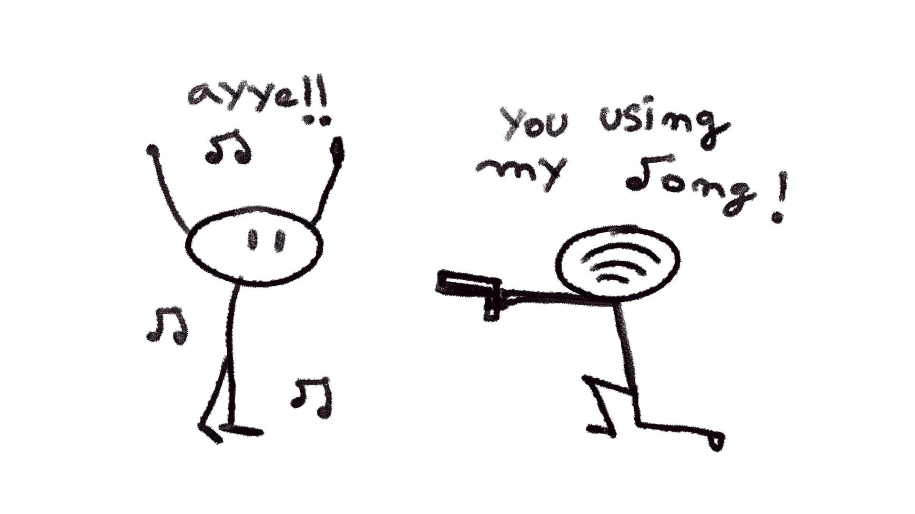

### **Music-Based Authentication**

Music-based authentication is a way of verifying someone's identity or access by using music or sound as a unique identifier. This method uses the special features of audio signals to improve security and create a more personal experience for the user. A key technique here is *audio fingerprinting*, which means analyzing the unique features of a piece of music. This creates a digital “fingerprint” of the audio that can be compared with stored patterns to check if it’s authentic.

### **Music-Based Authentication**

## 

## **Future of Music Encryption**

As the field of music encryption continues to evolve, its potential applications grow exponentially. Here’s what the future could hold:

### **Secure Bluetooth and Wireless Audio**

Imagine a world where your wireless headphones encrypt the sound they play, preventing eavesdropping or data theft. Encrypted audio waves could become the new standard for secure communication between Bluetooth devices, protecting everything from personal conversations to private documents transmitted over sound.

### **Enhanced Privacy**

In an era of increasing surveillance, music encryption could become a tool for those looking to secure their digital footprint. Whether it’s for journalists operating in hostile environments or individuals seeking to protect their privacy from corporations or governments, music encryption offers a stealthy, creative solution.

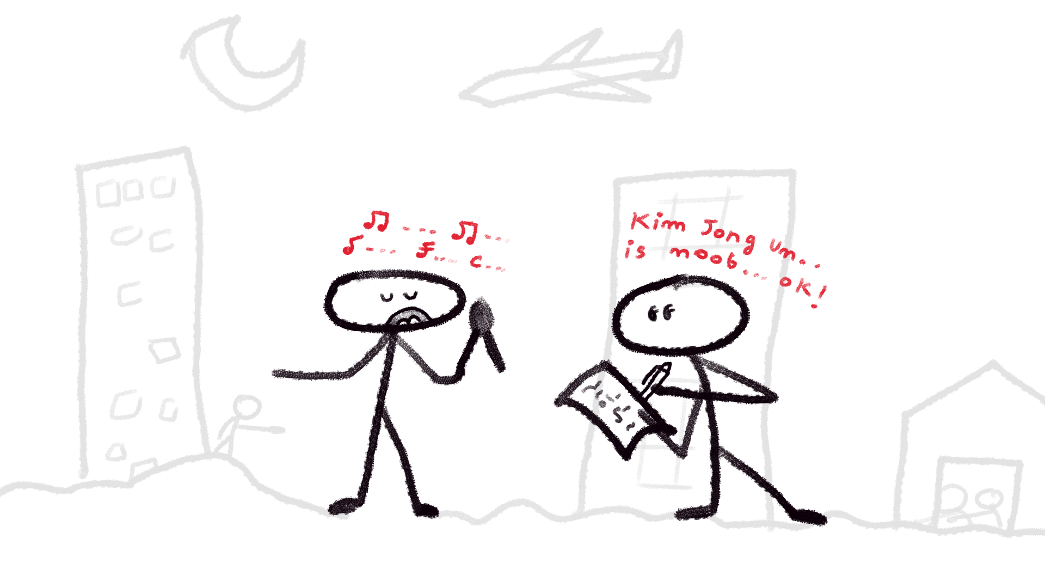

## **Challenges**

### **Compression Problems**

Many popular audio formats, such as MP3, use compression techniques to reduce file sizes. However, this compression can cause issues with encrypted data. Compressing an audio file may alter or lose some of its original information, including the hidden encrypted data. This distortion can compromise the integrity of the encrypted message, making it difficult or even impossible to decode correctly. While lossless audio formats like .wav or .flac can help preserve data integrity, compression remains a significant challenge. In the future, specialized audio formats for encryption might address this issue, but for now, this is the best we have.

### **Difficult to Standardize**

Music is a complex pattern made up of elements like pitch, volume, timbre, duration, tempo, and spatiality. This complexity makes it hard to standardize, which in turn makes it difficult for developers to create systems that work across different platforms. The lack of standardization means that building reliable, cross-platform solutions often requires a lot of custom work.

Music-based encryption lacks a unified set of guidelines. This absence of best practices can lead to inconsistencies and variations in how data is encrypted and decrypted, affecting reliability and security.

### **Early Stage of Development**

Music-based encryption is still in its developmental phase, unlike text-based encryption, which has been refined and studied for decades.

Music encryption systems have not faced the same rigorous scrutiny or cryptographic attacks as traditional encryption methods, making them a potentially weaker option until further research is conducted.

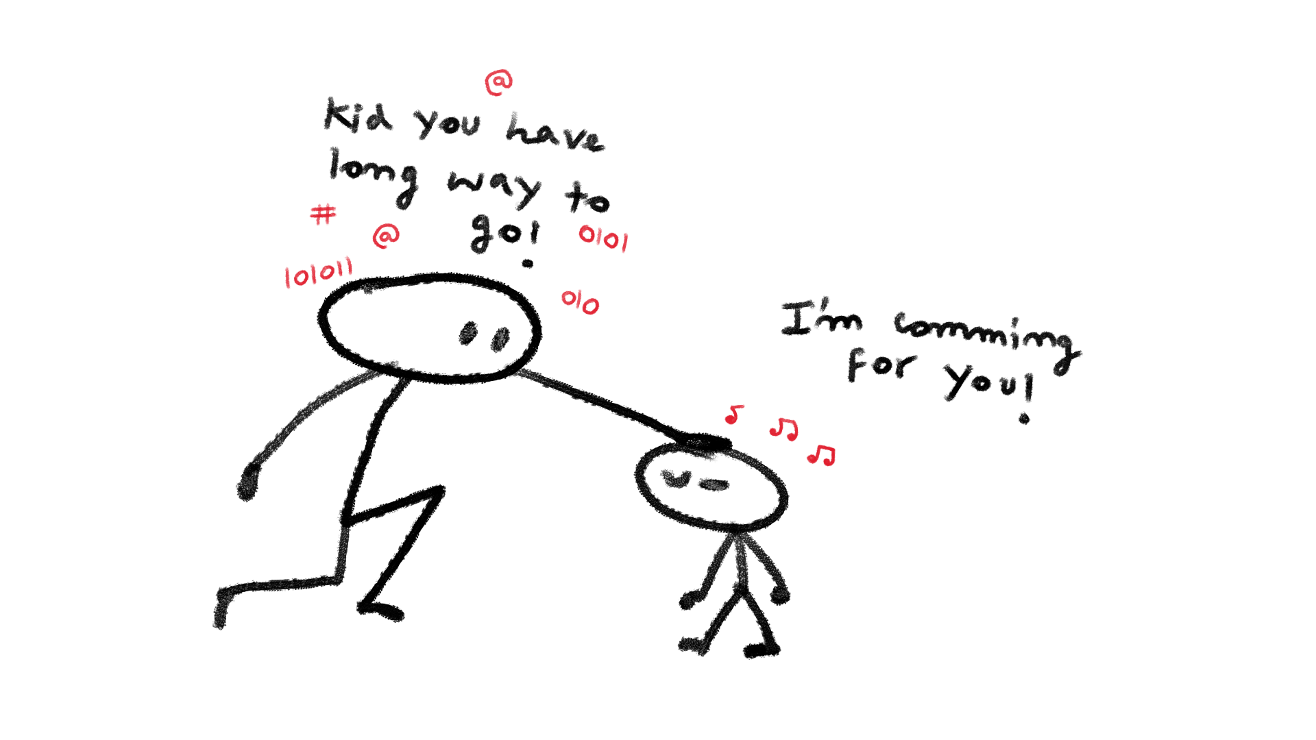

## **Conclusion**

Music encryption is like the next big leap in how we secure our data.

Music based Encryption needs a lot of research and community efforts to make it more real thing, it's a whole new creative approach compared to the usual text-based methods. As technology keeps growing, so does the potential of music encryption, and we might just be on the verge of something truly revolutionary. It’s no longer about how we read encrypted messages, but about how we hear them.

the field of music-based encryption and authentication is still in its early stages, with much research needed to improve its reliability and standardization. As individuals, we can support and explore this technology by staying informed and experimenting with its applications. In the future, we can expect more advanced and secure systems that use music for data protection, offering unique ways to enhance privacy and security. With continuous development, music encryption could become a powerful tool in our digital world.

In this new age of cryptography, music isn’t just for the soul—it’s becoming the next frontier in digital security.

***“Where words fail, music speaks,”***

***~ Hans Christian Andersen.***

Maybe soon, it’ll also protect!

1. [A Study of Encryption Algorithms AES, DES and RSA for Security](https://d1wqtxts1xzle7.cloudfront.net/103623264/4-A-Study-of-Encryption-Algorithms-libre.pdf?1687375898=&response-content-disposition=inline%3B+filename%3DA_Study_of_Encryption_Algorithms_AES_DES.pdf&Expires=1726381465&Signature=NIVpRWPWidG0PqTsm1caGwYf0oTLbrve8qoiDISBzAzCGh6ziKgUna9IrweQtg-7mHnrizW6S8bNRF3p73ligqAkZPwfIv27batZqW3k4KGzF2FDoORtWn2h4DxG4iV9QmNQlEbGs0E1aK1pvBVHuJDDRlfMkoDEzkTPPjbU4TiG~GiWhdf2UYk0g5HD3I6AW98l4TNd94JsChVLLKaSKes20Aoqt6hfYFfVXwnD0gkPHXUIr3nKbCp3AnDCeZacokXV9oxRkbEv3uXs-Hf5KsGRW1W~pLM6TH4B-M7fV~GYt8wdyHsDpWmEFxzsdd9zXnt6X6anRzeEXOUn55ydLw__&Key-Pair-Id=APKAJLOHF5GGSLRBV4ZA) 
2. [Lossless Audio Compression: A Case Study](https://esl.cise.ufl.edu/Publications/audioTR.pdf)
3. PAPER by Anurag Sinha and Tannisha Kundu - [An Approach to Musical Cryptography](https://d1wqtxts1xzle7.cloudfront.net/64993681/updated_paper-libre.pdf?1605935277=&response-content-disposition=inline%3B+filename%3DAn_Approach_to_Musical_Cryptography.pdf&Expires=1726383509&Signature=V39njdd38vvWBBNKY1L339FwALJQP-Tlt1~93bk8LmBjH~TAFlJ7FiXZWkkOy5GijUjjKOQ7VESTdpRrMgeBneHzmuCq-t9ZiprsA~xGULctxKq3qacTnw9jrSZCekYh9479T5PufB~xBoSCmjP19dqLxB7xHhC9JKOgxomy1qQ3LnpkYp2tbZGd2eYoM-VItW1iy9WjlNS-GhdSSTDLRuUSgtkdvoMmgZ7QznLAxn4MdZyVKg8sLXNueU7uGqcz3maDSxFYCT~cbxVamEt-4R-kDXVcEluDcsIT8jQHfThc6Vh-QZmhaIzMpKaUQg~ogS6CdNbnc3l39y9Diw9cBA__&Key-Pair-Id=APKAJLOHF5GGSLRBV4ZA)
4. AI-based Audio Watermarking : https://github.com/wavmark/wavmark